**1. Introduction**

1.1 Overview

Our Project is about Revenue and Market Penetration of iPhone. We intend to investigate how the iPhone has penetrated the markets and how much revenue generated though data analytics and Tableau visualizations.

1.2 Purpose

Through the insightful Visualizations and the analysis, we gain a comprehensive understanding of the iPhone's revenue streams and its extensive market reach. From these visual representations enabling us to capture the complexities of market penetration providing actionable insights to optimize strategies and capitalize on iPhone's market success.

**2. Problem Definition & Design Thinking**

2.1 Empathy map

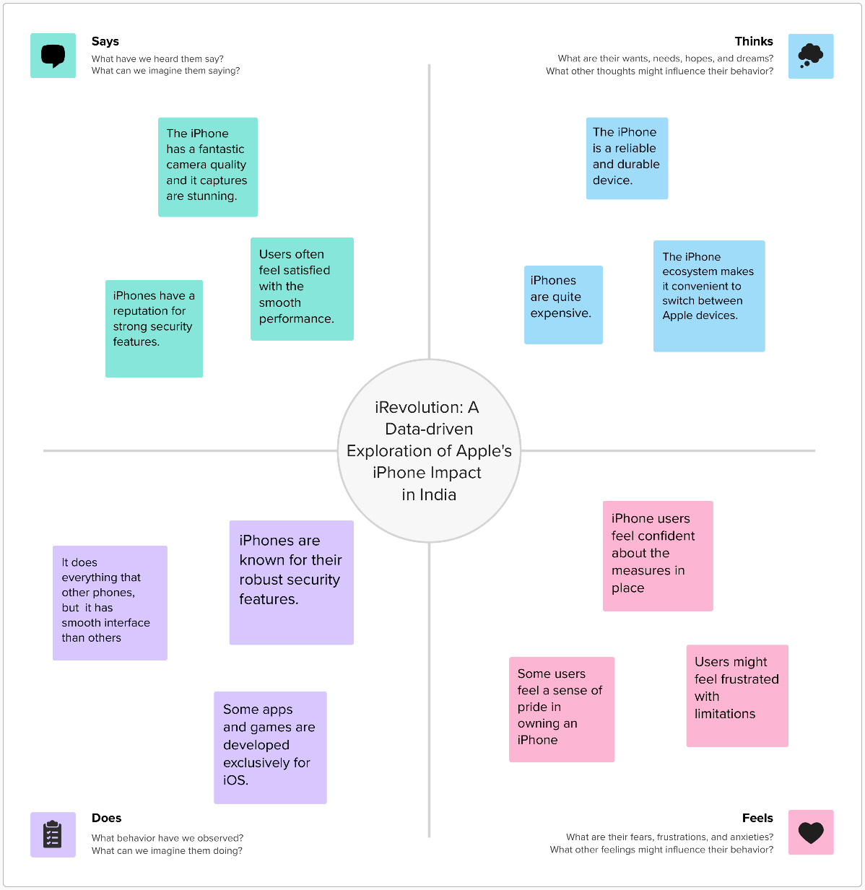

2.2 Ideation & Brainstorming map

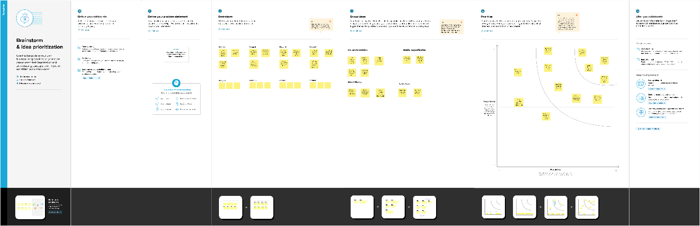

**3. RESULT**

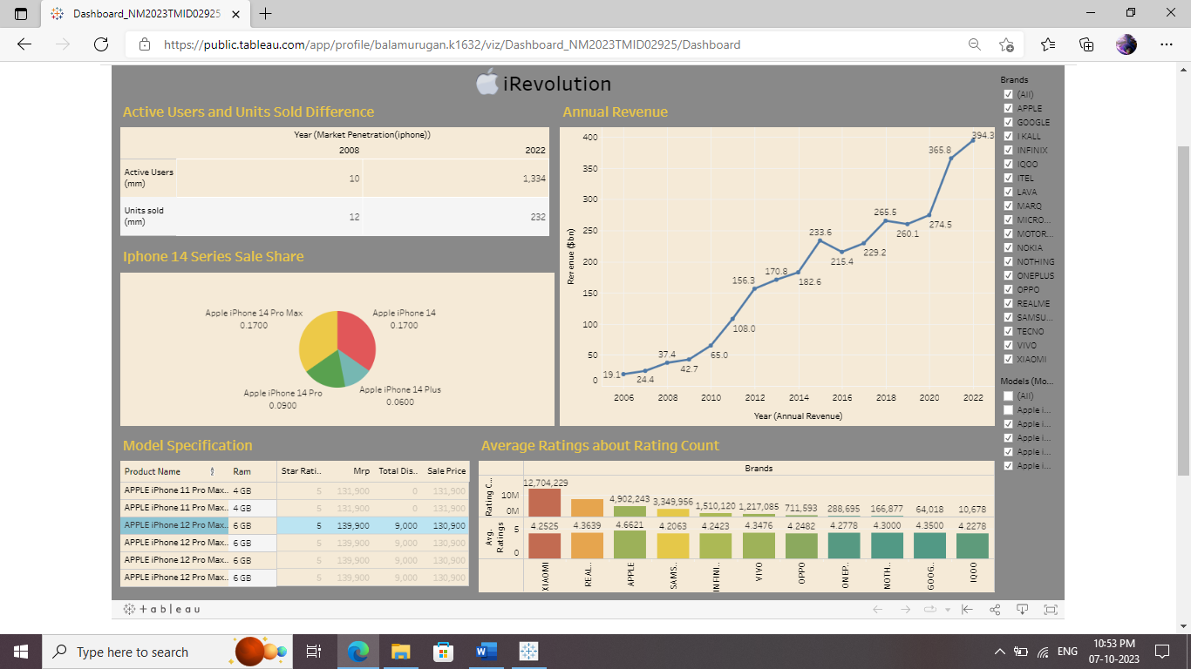

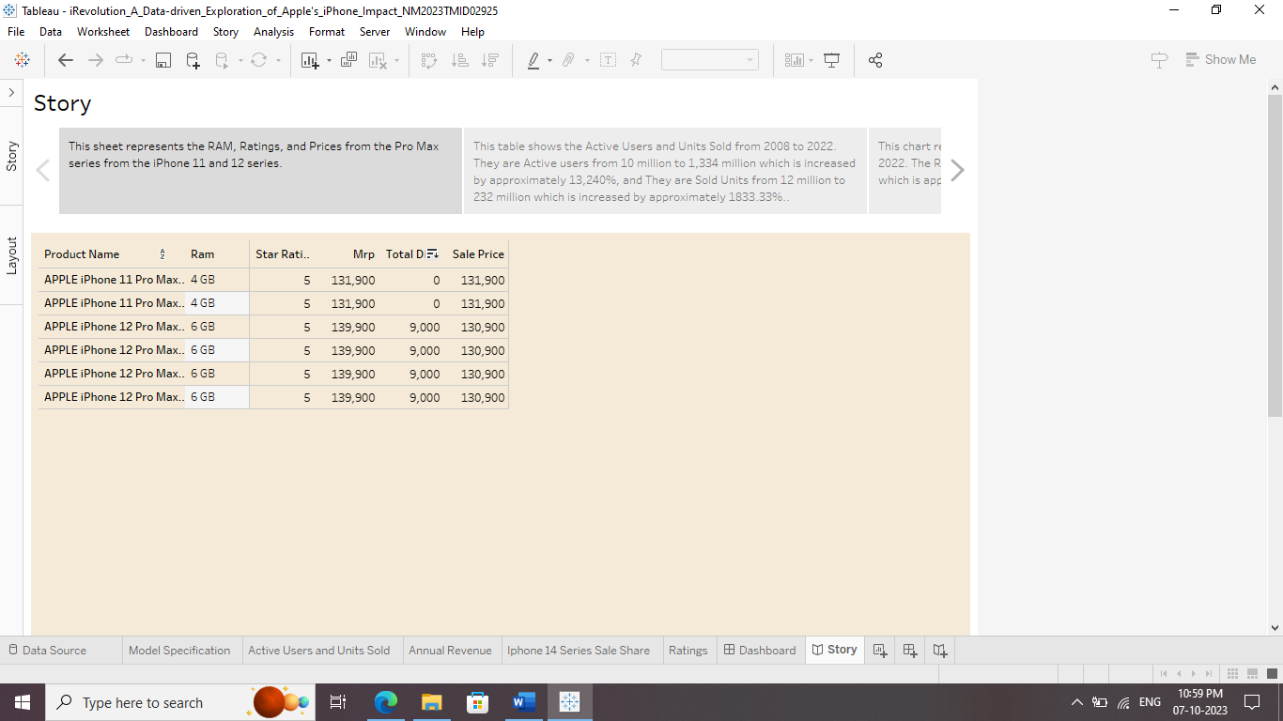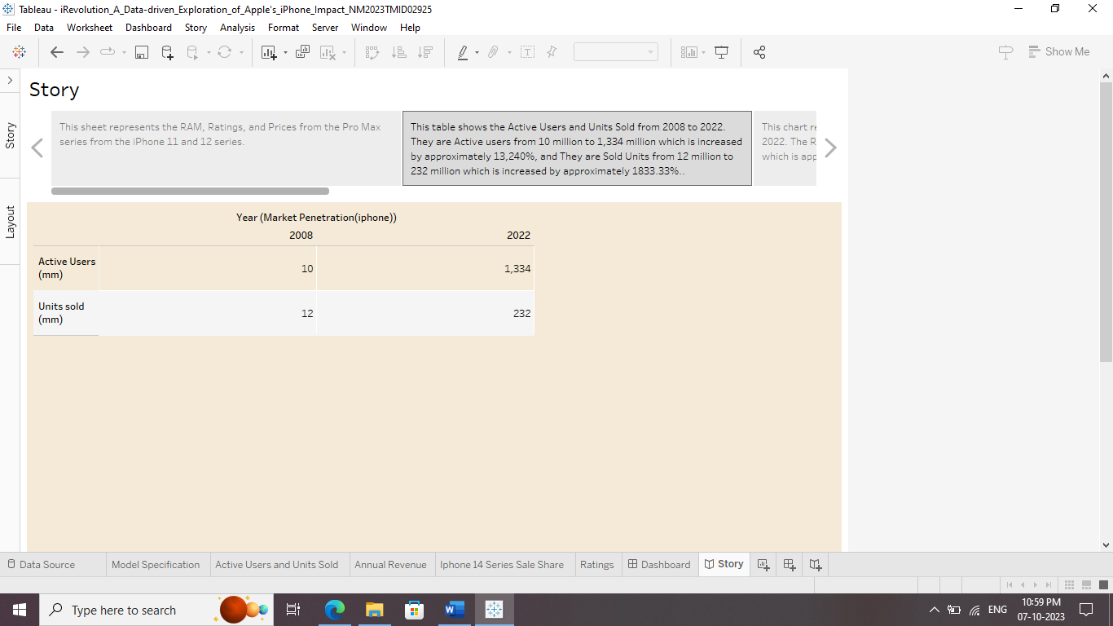

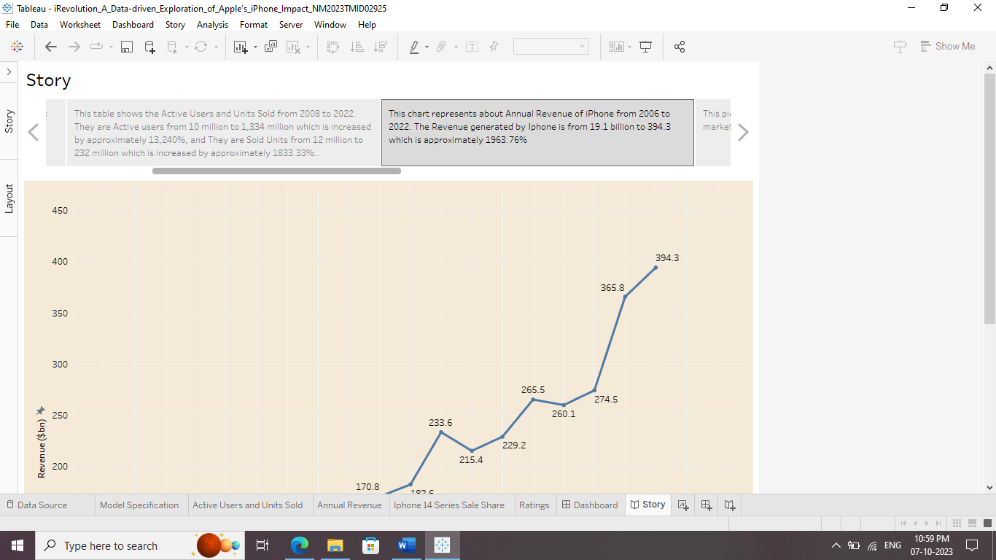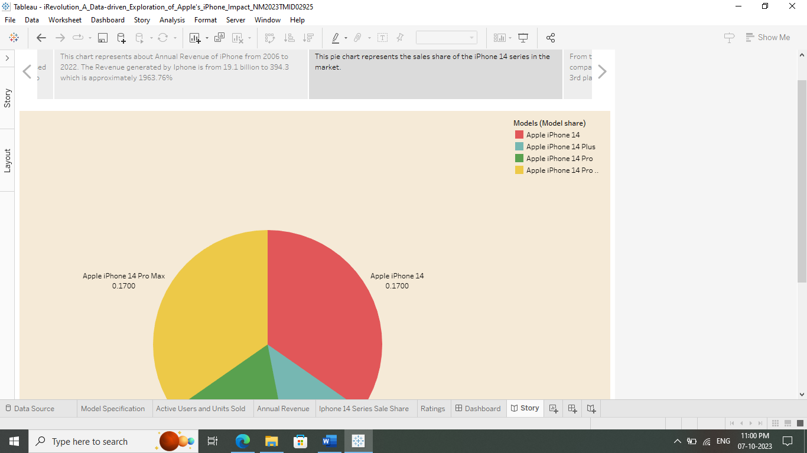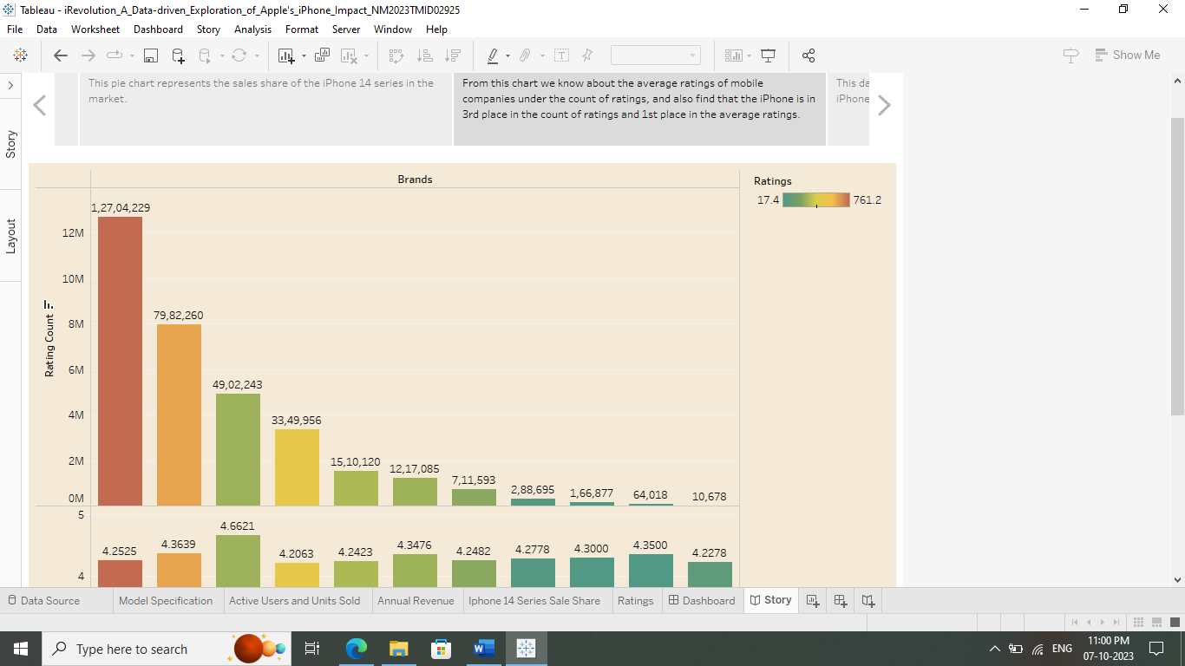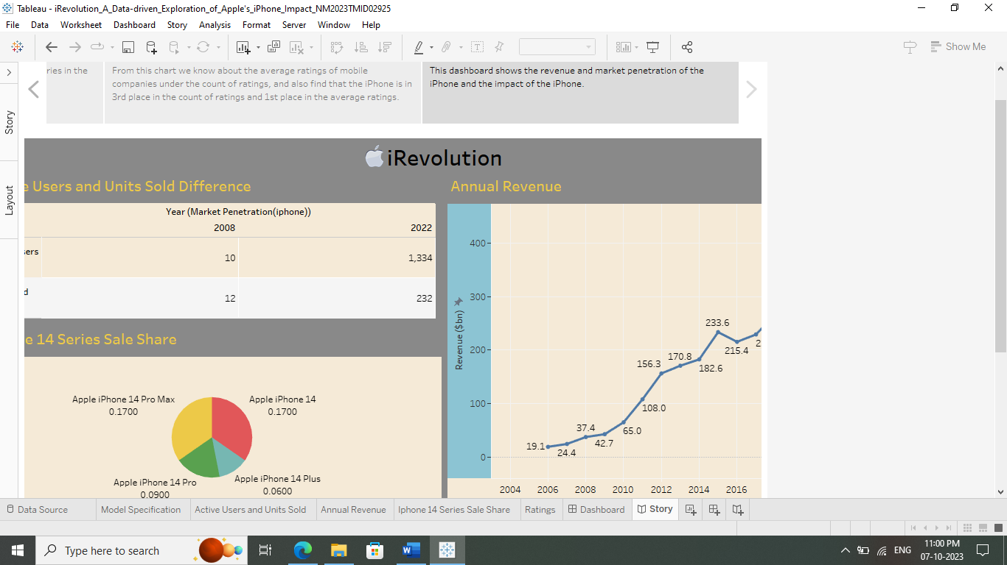

**4. ADVANTAGES & DISADVANTAGES**

* 1. Advantages

1. By spanning data from 2006 to 2022, it enables a historical analysis, which is crucial for understanding the iPhone's evolution over time.
2. Expressing the increase in active users, sold units, and revenue in percentage terms provides a clear understanding of the growth rates.
3. The sheets provide a wide array of information, including RAM, ratings, prices, active users, units sold, and annual revenue.
4. The combination of tables and charts enhances data visualization, making it easier for readers to comprehend complex information.
   1. Disadvantages
5. While the data is detailed, it lacks specific context for certain figures.
6. The representation lacks qualitative data such as customer reviews or feedback, which could provide a more nuanced understanding of customer preferences and satisfaction.
7. The data is historical, providing a retrospective view. Including future projections or market forecasts would make the information more actionable for businesses and analysts.
8. While the iPhone's data is detailed, a comparison with similar data from competitors would provide a broader perspective, allowing for a more comprehensive analysis of its market position.

**5. APPLICATIONS**

1. By studying the trends in active users, units sold, and revenue, analysts can identify patterns and make predictions about future market behaviour.
2. Businesses, especially those in the technology sector, can use this data to formulate strategic plans. Understanding the increase in active users and units sold helps in anticipating market demand.
3. Companies involved in smartphone manufacturing can analyse the RAM, ratings, and prices data to understand consumer preferences.
4. Investors and financial analysts can utilize this data to assess the financial health and growth potential of Apple Inc.
5. Marketers can use the data on active users and units sold to target specific demographics effectively.
6. By analysing the average ratings data, companies can gain insights into customer satisfaction levels.

**6. CONCLUSION**

This data sheet presents a comprehensive overview of the iPhone Pro Max series, focusing on the 11 and 12 models. Active users surged from 10 million to 1,334 million (a 13,240% increase), with units sold rising from 12 million to 232 million (an 1833.33% increase) by 2022. Annual revenue witnessed an exponential growth from 19.1 billion to 394.3 billion (a 1963.76% increase) from 2006 to 2022. Despite being ranked 3rd in the count of ratings, the Pro Max series claimed the top spot in average ratings, showcasing exceptional consumer satisfaction and market dominance. This data underscores Apple's unparalleled success, emphasizing both its massive market reach and remarkable customer loyalty.

**7. FUTURE SCOPE**

The data presented in this sheets not only offers a historical perspective on the iPhone Pro Max series but also provides invaluable insights for future analysis. Researchers and market analysts can utilize this data to forecast market trends and consumer preferences, aiding in the development of future iPhone models and pricing strategies. Businesses can leverage this information to anticipate demand, optimize supply chains, and enhance customer satisfaction. Investors can use these trends to make informed decisions, while policymakers can gauge the tech industry's economic impact. Furthermore, this data could be instrumental in guiding innovations and ensuring Apple's continued market leadership.